# HTTP1.1 vs HTTP2

## HTTP

**HTTP** stands for **H**yper **T**ext **T**ransfer **P**rotocol

**WWW** is about communication between web **clients** and **servers**

Communication between client computers and web servers is done by sending **HTTP Requests** and receiving **HTTP Responses**

For instance, when someone navigates to cloudflare.com on their laptop, their web browser sends an HTTP request to the Cloudflare servers for the content that appears on the page. Then, Cloudflare servers send HTTP responses with the text, images, and formatting that the browser displays to the user.

**HTTP1 loads a single request for every TCP connection, while HTTP2 avoids network delay by using multiplexing**.

HTTP is a network delay sensitive protocol in the sense that if there is less network delay, then the page loads faster.

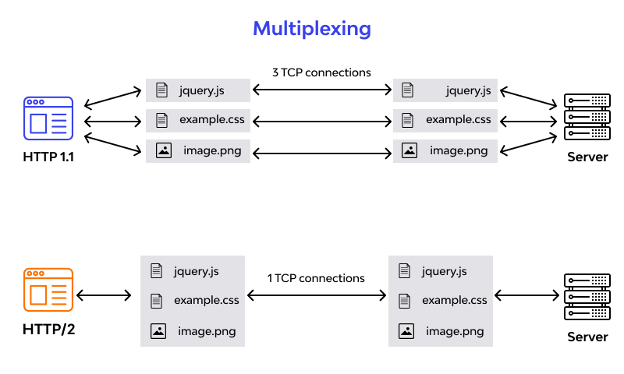

## HTTP 1.1

* Key Features

It supports connection reuse i.e. for every TCP connection there could be multiple requests and responses, and pipelining where the client can request several resources from the server at once. However, pipelining was hard to implement due to issues such as head-of-line blocking and was not a feasible solution.

* Status Code

Introduces a warning header field to carry additional information about the status of a message. Can define 24 status codes, error reporting is quicker and more efficient.

* Authentication Mechanism

It is relatively secure since it uses digest authentication, NTLM authentication

* Caching

Expands on the caching support by using additional headers like cache-control, conditional headers like If-Match and by using entity tags.

* Web Traffic

HTTP/1.1 provides faster delivery of web pages and reduces web traffic as compared to HTTP/1.0. However, TCP starts slowly and with domain sharding (resources can be downloaded simultaneously by using multiple domains), connection reuse and pipelining, there is an increased risk of network congestion.

## HTTP 2.0

* Uses multiplexing, where over a single TCP connection resources to be delivered are interleaved and arrive at the client almost at the same time. It is done using streams which can be prioritized, can have dependencies and individual flow control. It also provides a feature called server push that allows the server to send data that the client will need but has not yet requested.
* Status Code

Underlying semantics of HTTP such as headers, status codes remains the same.

* Authentication Mechanism

Security concerns from previous versions will continue to be seen in HTTP/2. However, it is better equipped to deal with them due to new TLS features like connection error of type Inadequate_Security.

* Caching

HTTP/2 does not change much in terms of caching. With the server push feature if the client finds the resources are already present in the cache, it can cancel the pushed stream.

* Web Traffic

HTTP/2 utilizes multiplexing and server push to effectively reduce the page load time by a greater margin along with being less sensitive to network delays.